**Introduction to the Data Import Wizard for Salesforce**

When importing data into Salesforce, there are multiple tools available for handling the import process. The first tool that is typically recommended to new Salesforce Administrators is Salesforce’s Data Import Wizard.

The Data Import Wizard tool can be used to seamlessly import, update, or upsert data into multiple standard objects and custom objects within Salesforce. Through a very user-friendly screen progression, you are able to configure parameters, data sources, and field mappings to ensure that your data stays clean within Salesforce – an essential ‘best practice’ in data management.

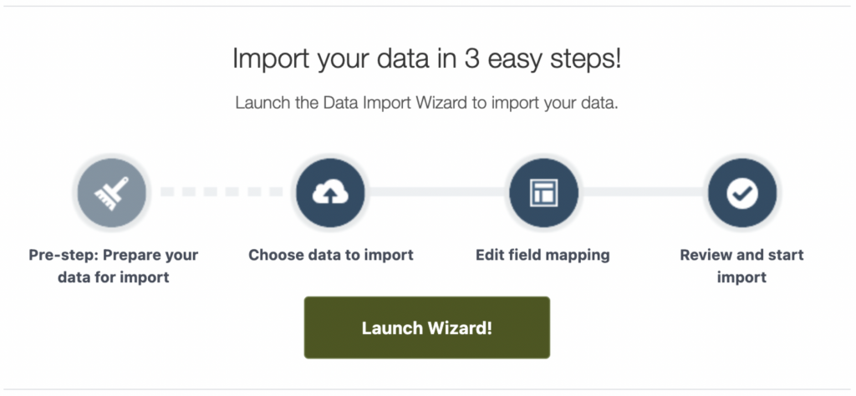

Data Import Wizard Features

The Data Import Wizard is available as an out-of-the box tool, and is accessible through your Salesforce environment – so there is no additional work needed to set it up. This versatile tool is the perfect option when importing Contact or Account data. The other standard objects that can have data imported into them through this tool are:

Leads

Solutions

Campaign Members

Person Accounts (if enabled)

Along with these objects, you can use the tool with any custom objects that are unique to your Salesforce environment.

Due to the limitations in the objects available when using the Data Import Wizard tool, it is typically used when managing initial persona data (including Contacts, Accounts, and Leads). However, there are some helpful features that make this importing tool beneficial, such as de-duplication, assigning Contacts to Campaigns, and triggering any automations on import.

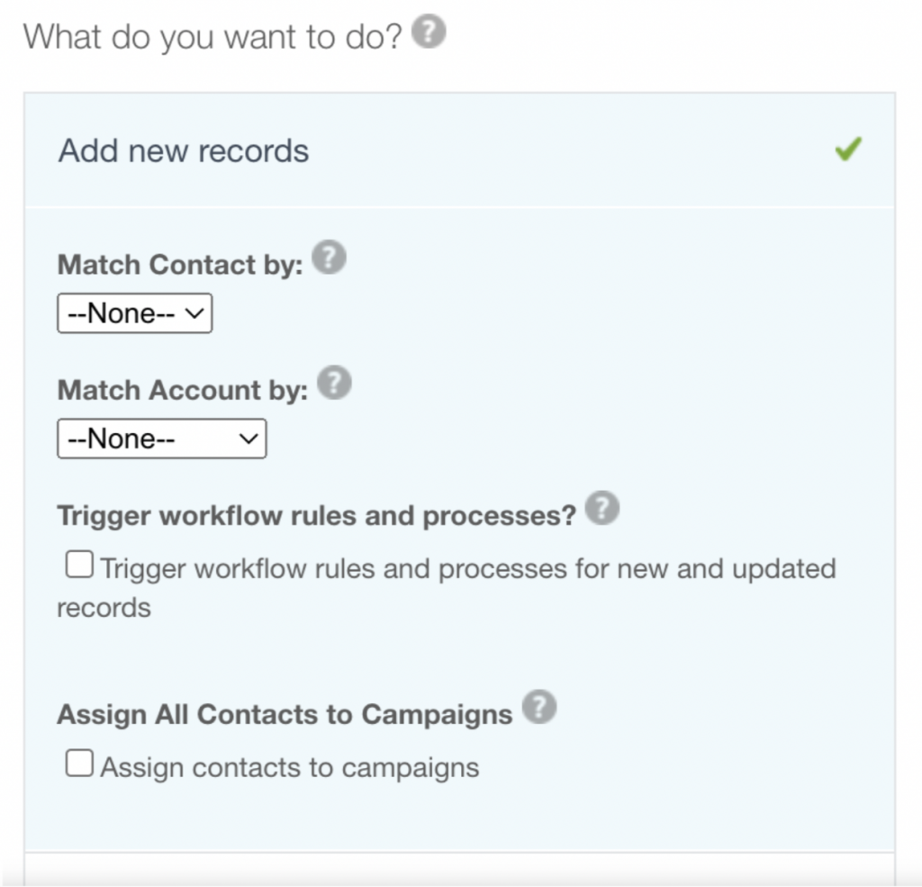

When importing Contacts and Accounts, you are able to set a field that Salesforce will do a match on to determine if the record already exists within Salesforce. For Contacts, you are able to match on Name and Email when importing new records, and on Contact ID when updating or upserting records.

For Accounts, you are only able to match on Name & Site together when importing new records, and on Accounts ID when updating or upserting records. If your organization has any external ID fields on either object, you are also able to match on those fields when importing.

There are additional features available when you look to import new Lead records into Salesforce through the Data Import Wizard, such as assigning a Lead Source and specifying Lead Assignment Rules. These features may not be beneficial if you are already populating the Lead Source and Lead Owner fields in your import file.

It’s also worth noting that Workflow Rules and Processes will always fire when using Data Loader. However, when using the Data Import Wizard, you have the option to toggle them on and off.

Data Import Wizard Considerations

As with any Salesforce feature/tool, there are considerations that you should be aware of before making a start:

Number of Records per File: Files imported through the Data Import Wizard are limited to 50,000 records at a time.

Size of File: Files imported through the Data Import Wizard are limited to 100 MB, while zip files are limited to 32 MB.

Objects Supported: There is a limited amount of objects supported by the Data Import Wizard (as mentioned above). The standard objects that are not supported through this tool include:

1. Assets
2. Cases
3. Campaigns
4. Contracts
5. Documents
6. Opportunities
7. Products

Number of Fields Per File: Files imported through the Data Import Wizard are limited to 90 fields at a time.

Operations Available: The Data Import Wizard is limited to only three functions: upload, upsert, update. There is no feature to export or delete records through the tool.

Import Process

Now that you understand what is and is not possible with the Data Import Wizard, you might be wondering how this all comes together with an actual import.

Once you have determined which object you are importing to, and whether you are performing an insert, update, or upsert, you must then provide a .csv file for the upload. This is very important to note as regular Excel files are not acceptable for these data import processes.

There are multiple choices when selecting where your data is located; typically organizations will either drag a .csv file into the Import Wizard or browse their computer documents to select the appropriate file. 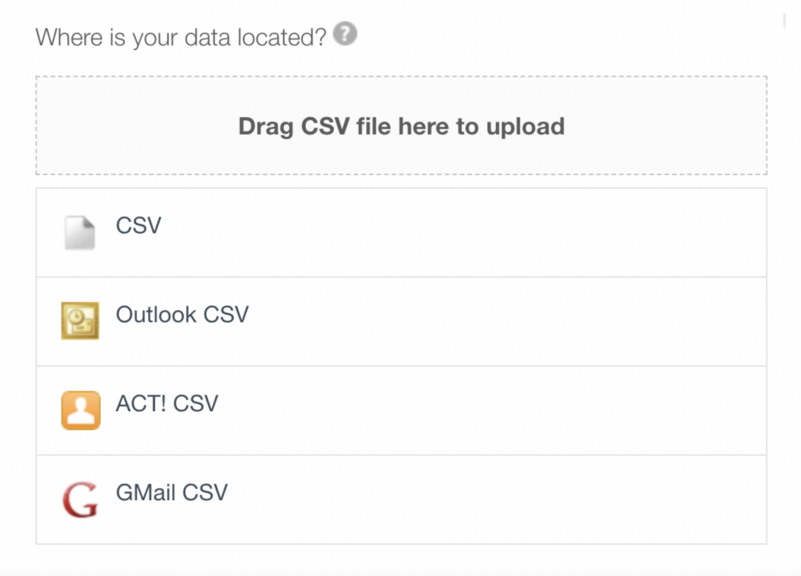

The second step in any import process is mapping the fields from your file to the fields you have available within your Salesforce instance.

The Data Import Wizard will try to automatically match fields for you – providing the headers in your file resemble the fields in Salesforce for the object(s) you are importing to. You will be able to change any of the mappings that were automatically completed for you if the fields that Salesforce found were not the fields that you wanted to map to.

Any field that Salesforce was unable to map for you will show as “Unmapped” on this screen. It is not necessary to map every column in your .csv file to a Salesforce field unless that field is required (like Last Name for the Contact object or Account Name for the Account object).

It is also possible to map a header to multiple fields as well, such as a column holding a phone number being mapped to the Account phone and Contact phone fields.

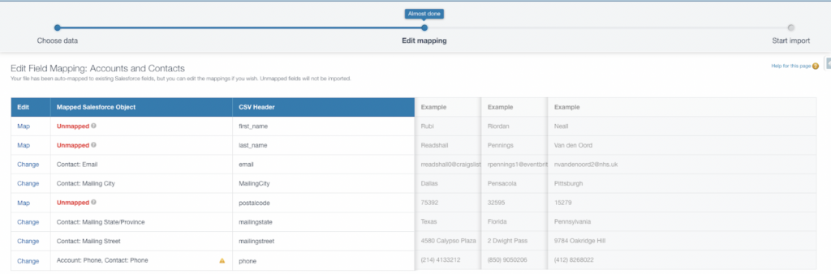

Once the field mapping is complete, there is a final confirmation screen that outlines how many fields are being mapped and how many are not being mapped.

When you start the import process you are able to view its progress by navigating to the Bulk Data Load Jobs section of Salesforce Setup.

Summary

The Data Import Wizard is one of various tools available to Salesforce users for importing data. The tool is best used when importing data into the Account, Contact, Lead, or Solution objects along with any custom objects within your Salesforce organization.

There are some considerations when using the tool, but the import process is smooth and easy to understand. Stay tuned for another article which pits the Data Import Wizard against the Data Loader to determine which is best for various scenarios.